User Document

Pinaka & Asthra

**TABLE OF CONTENTS:**

**1.Introduction**

**2.User Manual:Pinaka**

**3.User Manual:Astra**

**4.Contact Us**

**1.Introduction**

#### **Overview**

Medpick is a B2C medical supply store supplying a wide range of consumer products across various parts of New England. Our collection of Products include Consumer Goods, Home Healthcare Devices such as Nebulizers and Blood Pressure Monitors, and Disposables such as 3-Ply Ear Loop Face Masks. We aim to serve Medical Product Procurement and Delivery at Affordable Costs and ensure 100% Customer Satisfaction. Medpick is owned and managed by Physicians and has an efficient team of well-informed nerds who stand prepared to be of your service, anywhere, anytime.

**Vision**: To Make Personal Health accessible to Every Individual in the States.

**Mission**: Our sole mission is to simplify the lives of people who are in constant need of Personal Health Equipment and consumer goods; with Medpick’s Exceptional choice of Products and Unique Services. We aim to serve Medical Product Procurement and Delivery at Affordable Costs and ensure 100% Customer Satisfaction.

**Why Medpick**? Variety in Product Collection; Our products promise diversity. One can enjoy a wide selection of products from our compilation of medical supplies such as disposables and home healthcare devices.

**Exceptional Services**: Medpick aims to ensure a good life for our clients. We provide unbeaten Customer Services and ensure well-timed product delivery.

**Expertise**: Our knowledgeable team members are available to respond to your queries or assist you with any product of your choice.

**Time-Bound**: We believe that Time, is Priceless. Hence, we also strive to provide fast delivery and customer services as early as possible.

## **2.User Manual:Pinaka**

**For customers:** Download the app from playstore and sign in using email id/facebook

## **HOW TO USE PINAKA?**

|  |  |
| --- | --- |
|  | Take a picture of your prescription and upload it on the app |
|  | Choose your desired retail pharmacy to send your prescription |
|  | Get confirmation of your order pick up, or get it delivered to your doorstep, or pick it up from the nearest **MedBOX**. |

## **THE ESSENCE OF PINAKA**

***Pinaka*** or Shiva Dhanush in ***Sanskrit*** is the bow of the Hindu god Shiva; which means ‘that which protects’ . Here, Pinaka resembles the weapon of Retail Pharmacies to use against Online Pharmacies, and protect themselves from running out of Business.

## WHY PINAKA?

###### a. One Stop for all your medicinal needs

Running about the complete locality with your prescription is a hectic task when all of the medications aren’t available in a single store. With Pinaka, order and allow a single pharmacy near you, to keep all the medications ready for you!

###### b. Time-saver

Real-time emergencies like medicines and drugs are needed immediately by consumers; hence they can’t wait for 3-4 days for an order to get delivered. With Pinaka, order your medications and pickup from the store (or get it delivered), all on the same day!

###### c. Assured Privacy

The Medbox locker tends to 100% privacy of your medicinal needs, where your medications will be delivered and only you can receive it with the help of the OTP sent to your mobile device.

**User Manual: Asthra**

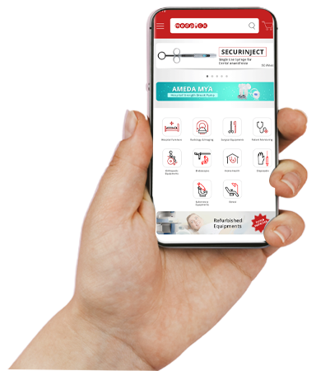

# Hospitals

You’re a primary Healthcare Provider, but procurement of medical equipment is a very lengthy chore for you. How do you make it simple?

With Asthra by your side, you can swiftly order and buy any medical equipment needed at your organization. Establishing a direct business with suppliers around the nation at competitive prices is now possible, from your personal mobile device.

Asthra is designed to provide easy procurement of medical devices by implementing key functions such as:-

|  |  |
| --- | --- |
|  | Hassle-free procurement in the absence of multiple tiers of communication |
|  | Explore categories like Surgical, Radiology, Disposables, and Hospital Furniture |
|  | Purchase equipment at a much cheaper rate than the market price |
|  | Swift Delivery |
|  | Smooth tracking of orders |

To avail of these features, all you need to do is Install and Sign up on the Asthra app.

# Vendors

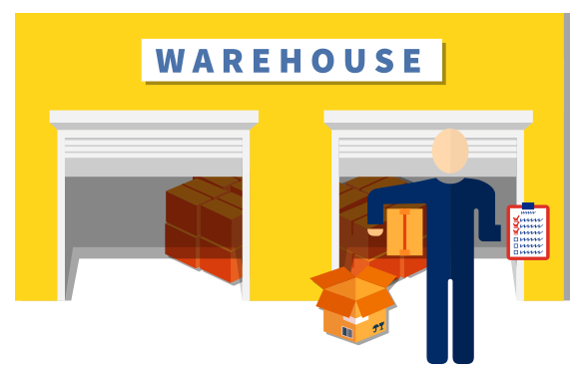

How long have you had to wait for your payment due to lengthy payment processing schedules?  
Did you have to battle against inconsistent order flow?  
Why Worry?

Install ***Asthra*** and Sign up with Medpick now!!

Once enrolled with Asthra, you get exclusive access to showcase your products to multiple hospitals and laboratories all over India, at a single time.

One can enjoy features like

|  |  |
| --- | --- |
|  | Increased sales traffic by connecting with Pan India Hospitals. |
|  | Exposure and Promotions of your products through Asthra |
|  | Instant Payments |



# Dealers

If you’re a **Dealer** looking to source out supplies and equipment for your hospital network, **Medpick** aids you in procuring medical equipment ranging from Radiology to Hospital Furniture.

All you have to do is Sign Up and Install Medpick’s easy-to-use mobile app, Asthra.

**Asthra** is designed to help you

|  |  |
| --- | --- |
|  | Procure equipment at very reasonable prices for your network |
|  | Diverse categories of Medical equipment to choose from |
|  | Keep a check on price fluctuations according to the market |
|  | Earn Commissions by reselling products on Asthra |

# Diagnostic Laboratories

Get access to a compilation of India’s finest and fully-automated laboratory equipment at the click of your fingers, only on the Asthra app.

Asthra provides you with features such as

|  |  |
| --- | --- |
|  | A Stock of cutting-edge original laboratory machinery and rapid test kits. |
|  | Quality care at affordable costs |
|  | Win the benefit of Simple and smooth procurement process of diagnostic equipment |



# Pharmacies



Through Asthra, you can achieve a continuous flow of sales and save your retail pharmacy from getting pulled-down in the era of online pharmacies.

#### How??

Medpick connects all local pharmacies to receive prescriptions from customers through Asthra online. You will get notified of these orders on the Asthra app online and can pack the medications up for the consumers to pick up on the Go! With Medpick’s Medbox, home delivery of medications at apartments can also invite consumers to order online from you.

**How does it benefit you?**

|  |  |
| --- | --- |
|  | More orders flowing in from retail consumers |
|  | Save your business from dying out. |

**Here, you can also**

|  |  |
| --- | --- |
|  | Procure supplies swiftly from suppliers on our app |
|  | Receive Bulk orders from Hospitals and clinics. |

**4.Contact Us**

Medpick endeavors to reach anyone in need of primary healthcare services, and do good along the way.

**Medpick US:** 100 William T Morrissey Blvd, UMass Boston, Boston MA 02125

**Call** **us: (+1) 617-618-5094**

[**+91-74833-96329**](tel:+91-74833-96329)(India)

**+91-74833-96329(**India**)**

**Email**:

**contact@medpick.us**

**Website**

[**http://www.medpick.in**](http://www.medpick.in/)

**Industry**

Hospital & Health Care

**Headquarters**

Bengaluru, Karnataka